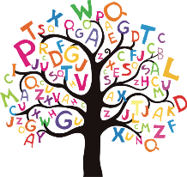How dyslexic is my child?

Do any of these common symptoms sound familiar? Some or all of these symptoms may be present. Tick the statements that apply to your child.

Wealden Learning Support

**In nursery school**

* Has trouble recognising whether two words rhyme
* Struggles with taking away the beginning sound from a word
* Struggles with learning new words
* Has trouble recognising letters and matching them to sounds

**In primary school**

* Has trouble taking away the middle sound from a word
* Has trouble blending several sounds to make a word
* Often can’t recognize common sight words
* Quickly forgets how to spell many of the words she studies
* Gets confused by wordy maths problems
* Makes many spelling errors
* Frequently has to re-read sentences and passages
* Reads at a lower academic level than how she speaks
* Avoids reading aloud in class
* Has difficulty saying the right word e.g. ‘except’ for ‘exempt’
* Spells the same word differently on the same page
* Difficulty expressing ideas in an organised way with the right spelling,

grammar and punctuation

**In secondary school**

* Often skips over small words when reading aloud
* Doesn’t read at the expected level according to their overall ability
* Strongly prefers multiple-choice questions over fill-in-the-blank or short

answer questions

* Has trouble understanding joke punchlines, puns, proverbs and idioms
* Has difficulty supporting an argument or getting to the point
* Has trouble reading charts and graphs
* Struggles to learn a foreign language

Wealden Learning Support